Nama : Meuthia Bronthe

NIM : 09010182327012

Kelas : MI3A

Mata Kuliah : Praktikum Jarkom

MODUL 4 | SWITCHING

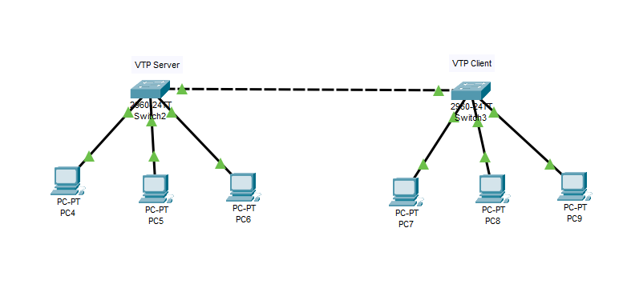

VTP SERVER

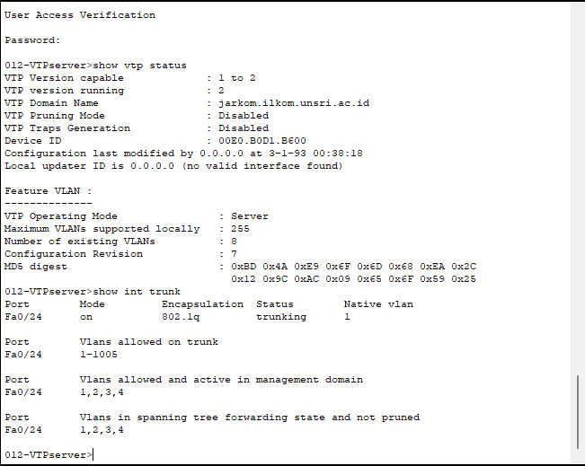

VTP CLIENT

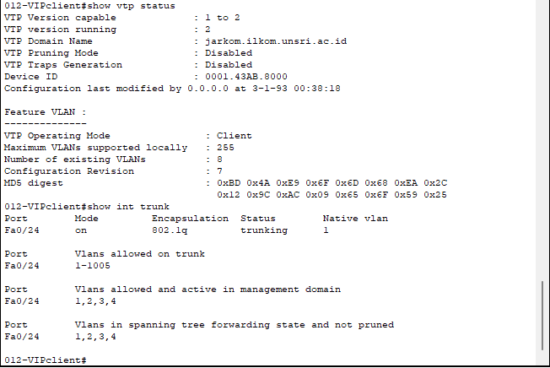

MODUL 5 | NAT

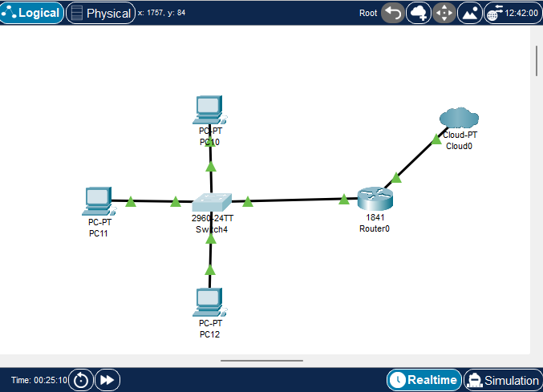

1. Konfigurasi Switching

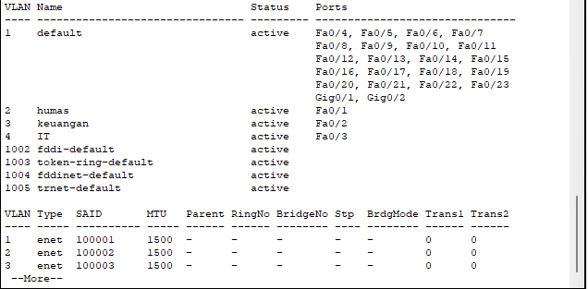

|  |  |  |  |
| --- | --- | --- | --- |
| **VLAN** | **NAME** | **STATUS** | **PORTS** |
| 1 | Default | Active | Fa0/4, Fa0/5, Fa0/6, Fa0/7  Fa0/8, Fa0/9, Fa0/10, Fa0/11  Fa0/12, Fa0/13, Fa0/14, Fa0/15  Fa0/16, Fa0/17, Fa0/18, Fa0/19  Fa0/20, Fa0/21, Fa0/22, Fa0/23  Gig0/1, Gig0/2 |
| 2 | Humas | Active | Fa0/1 |
| 3 | Keuangan | Active | Fa0/2 |
| 4 | IT | Active | Fa0/3 |
| 1002 | Fddi-default | Active |  |
| 1003 | Token-ring-default | Active |  |
| 1004 | Fddinet-default | Active |  |
| 1005 | Trnet-default | active |  |

1. Konfigurasi Router

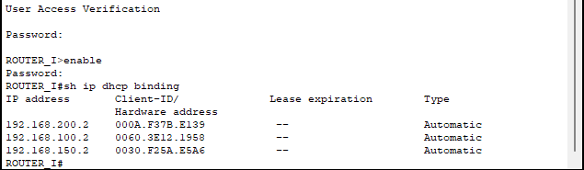

* **Melihat Daftar IP dari Client**

|  |  |  |  |  |
| --- | --- | --- | --- | --- |
| **NO** | **IP ADDRESS** | **HARDWARE**  **ADDRESS** | **LEASE EXPIRATION** | **TYPE** |
| 1. | 192.168.200.2 | 000A.F37B.E139 | -- | Automatic |
| 2. | 192.168.100.2 | 0060.3E12.1958 | -- | Automatic |
| 3. | 192.168.150.2 | 0030.F25A.E5A6 | -- | Automatic |

* **Daftar IP Clien**

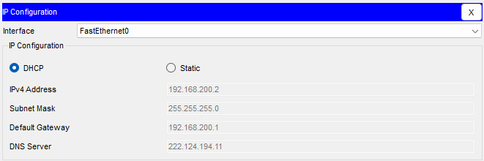

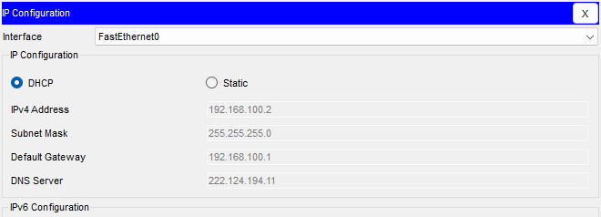

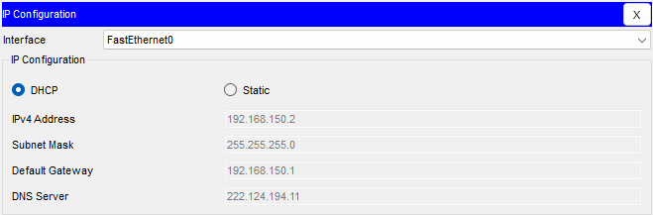

|  |  |  |  |  |  |
| --- | --- | --- | --- | --- | --- |
| **NO** | **CLIENT** | **IP ADDRESS** | **NETMASK** | **GATEWAY** | **DNS** |
| 1. | PC1 | 192.168.200.2 | 255.255.255.0 | 192.168.200.1 | 222.124.194.11 |
| 2. | PC2 | 192.168.100.2 | 255.255.255.0 | 192.168.100.1 | 222.124.194.11 |
| 3. | PC3 | 192.168.150.2 | 255.255.255.0 | 192.168.150.1 | 222.124.194.11 |

* **Tes Koneksi ke sebuah website (catat hasil yang anda dapat)**

|  |  |  |  |  |  |
| --- | --- | --- | --- | --- | --- |
| **NO** | **SUMBER** | **IP GATEWAY** | **HASIL** | **WEBSITE** | **HASIL** |
| **YA / TIDAK** | **YA / TIDAK** |
| 1. | PC1 | 192.168.200.1 | TIDAK | [www.google.com](http://www.google.com) | TIDAK |
| 2. | PC2 | 192.168.100.1 | TIDAK | [www.google.com](http://www.google.com) | TIDAK |
| 3. | PC3 | 192.168.150.1 | TIDAK | [www.google.com](http://www.google.com) | TIDAK |